# CH11 Hypotheses- Buena School District Bus Data

From the data set3 – “Buena School District Bus Data**”, I want to see if there is a difference in bus type (Diesel and Gasoline) mean maintenance price at the 0.05 significance level**.

1. Based on bus type: diesel and gasoline, I picked up data in Maitenance column and generated data looks like bellow:



1. State the Hypotheses:

H0: μDiesel = μGasoline

H1: μDiesel  ≠ μGasoline

1. From Megastat, I got:



1. P-value is .2980. It is bigger than α =.05. So, we can’t reject H0.

**In the conclusion: we can’t see difference in bus type (Diesel and Gasoline) mean maintenance price.**

# CH11 Hypotheses- Applewood

From the data set – “Applewood**”, I want to see if there is a difference in mean price for people’s age under 45 and older than 45**.

1. Based on age, I separated the data from PROFIT column and generated data looks like bellow:



1. State the Hypotheses:

H0: μa<=45 = μa>45

H1: μa<=45  ≠ μa>45

1. From Megastat, I got: 
2. P-value is .0009. It is smaller than α =.05. So, we can reject H0. And we can also see that the mean of age<=45 is less than age>45.

**In the conclusion: there is a difference in mean price for people’s age under 45 and older than 45. The elder people are willing to buy more expensive car.**

# CH11 Hypotheses – International

From the data set – “International**”, I want to see if there is a difference in mean GDP of countries in G-20 and nomember of G-20.**

1. Based on G-20 membership, I separated the data from GDP column and generated data looks like bellow:



1. State the Hypotheses:

H0: μG20 = μN

H1: μG20  ≠ μN

1. From Megastat, I got: 
2. P-value is .3992. It is bigger than α =.05. So, we can’t reject H0.

**In the conclusion: we can’t see difference in mean GDP of the countries who are member of G-20 and non-member.**

# CH12 ANOVA - Buena School District Bus Data

From the data set3 – “Buena School District Bus Data**”, I want to see if there is a difference in bus manufacture (bus-MFG) mean miles at the 0.05 significance level**.

1. Based on bus-MFG: Bluebird, Keiser and Thompson, I picked up data in Miles column and generated data something like bellow:



1. State the Hypotheses: H0: μB = μK = μTh H1: The mean miles are not all equal.
2. From Megastat, I got following info:



1. P-value is .2415. It is bigger than α =.05. So, we can’t reject H0.

**In the conclusion: we can’t see difference in bus manufacture (bus-MFG) mean miles.**

1. The Tukey interpretation:

* P-value of comparing “Keiser” and “Bluebird” is .1425, it is bigger than α =.05. So we can’t reject H0: μB = μK. There is no difference in “Keiser” and “Bluebird” mean miles.
* P-value of comparing “Keiser” and “Thompson” is .1789, it is bigger than α =.05. So we can’t reject H0: μTh = μK. There is no difference in “Keiser” and “Thompson” mean miles.
* P-value of comparing “Thompson” and “Bluebird” is .6316, it is bigger than α =.05. So we can’t reject H0: μB = μTh. There is no difference in “Thompson” and “Bluebird” mean miles.

# CH12 40



1. State the hypotheses as bellow:

H0: μM= μI = μU = μR

H1: The mean number sold among the four restaurants are not all equal.

From the Megastat, we get **the Treatments p-value .0717**.

The p-value is more than .05 significance level. So, **we can’t reject H0 (null hypotheses).**

**In the conclusion:** with .05 significance level, there is no difference in the mean number sold among the four restaurants.

1. State the hypotheses as bellow:

H0: μW1= μW2= μW3= μW4= μW5= μW6

H1: The mean number sold from Week1 to Week6 are not all equal.

From the Megastat, we get **the Blocks p-value .1488**.

The p-value is more than .05 significance level. So, **we can’t reject H0 (null hypotheses).**

**In the conclusion:** with .05 significance level, there is no difference in the mean number sold among week1, week2, week3, week4, week5 and week6.

# CH12 48



1. Interaction plot of the detergent means by cycle time:

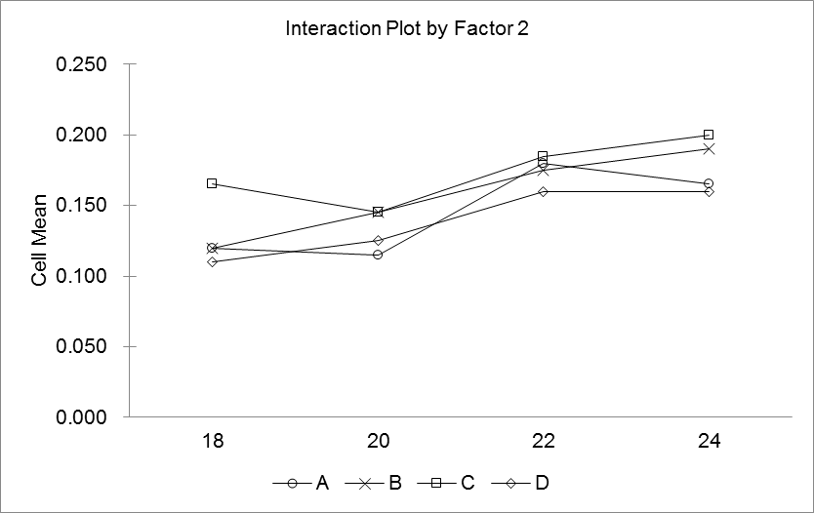

1. State the hypotheses:

H0: There is no interaction between factor1 and factor2.

H1: There is interaction between factor1 and factor2.

From the Megastat, we get **the interaction p-value .3860**.

The p-value is more than .05 significance level. So, **we can’t reject H0 (null hypotheses).**

**In the conclusion:** with .05 significance level, there is no interaction between brand and cycle time on “dirt removed”.

1. State the hypotheses:

H0: the brand means are the same.

H1: the brand means are not the same.

From the Megastat, we get **the brand p-value .0010**.

The p-value is less than .05 significance level. So, **we can reject H0 (null hypotheses).**

**In the conclusion:** with .05 significance level, the brand means are not the same.

1. State the hypotheses:

H0: the cycle time means are the same.

H1: the cycle time means are not the same.

From the Megastat, we get **the cycle time p-value 1.68E-06**.

The p-value is less than .05 significance level. So, **we can reject H0 (null hypotheses).**

**In the conclusion:** with .05 significance level, the cycle time means are not the same.